第六届”外研社杯”全国高职高专英语写作大赛
英语专业组复赛样题
National English Writing Contest
For Technical and Vocational College Students

Part I (50 points)
Directions: People go to work in different ways. Please study the following chart, write a short report to present the information and give your suggestions. Write more than 200 words.
Ways People Going to Work in 2012 in UK
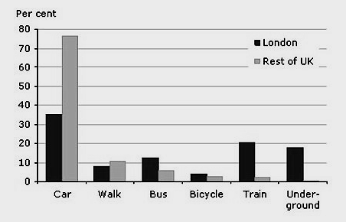
Part II (50points)
Directions: Charles Furniture Company is going to attend the 23rd World Furniture Exhibition in Jingkou. You are the sales assistant of the company. Please write a letter of invitation (more than 350 words) to Mr. Blanch, the purchasing manager of Middlemarch, one of your VIP clients. Please include the following information in your letter:
The name, time and venue of the exhibition
The new products you will launch
The enclosure in your letter (a map and a detailed program of the Fair)
Your strong wish for the client to take look at your exhibition.

