第六届“外研社杯”全国高职高专英语写作大赛
公共英语组复赛样题
National English Writing Contest
For Technical and Vocational College Students

Part I (50 points)
Directions: Weston Electronics Company, an important client of your company, is going to have a party to celebrate its fifth anniversary on the 10th of next month and you are invited to attend. Unfortunately you will be in another city on business then. Please write a letter（more than 100 words）to Mr. Williams, the manager of Weston to decline the invitation. The following points are for your reference:
Express congratulations
Express your thanks
Decline the invitation
Explain the reason
Express your good wishes
Other information you think necessary

Part II (50 points)
Directions: The following chart is the results of a study by the World Health Organization into the major causes of death-related illness and diseases in the world in the year xxxx. Please read the chart and write a short report (more than 350 words) about the results.
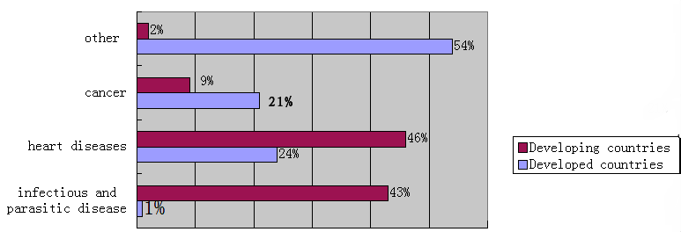
Note: heart disease心脏病 infectious and parasitic disease 感染与寄生虫疾病

